Self-Serve Printer Installation Guide

1. Close all Internet Explorer (IE) web browsers **(do NOT skip this step!)**
2. In the Windows Desktop Icon Tray (bottom right corner of desktop) there is a printer icon with a Blue printer picture, **right click** on this icon

cid:image001.png@01D4F138.8B6F8070

If you do not have this icon, go to the Service Gateway and proceed to open a ticket: <http://servicegateway-passerelledeservice.hc-sc.gc.ca/en/h-install-printers.html>

1. **Left click** on **“Find/Install printers”** (this will open a web page from which you will select the printer you want)

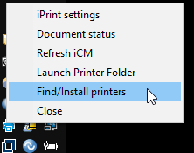

If you do not see “Find/Install printers” or experience other problems, go to the Service Gateway and proceed to open a ticket: <http://servicegateway-passerelledeservice.hc-sc.gc.ca/en/h-install-printers.html>

1. Once the web page opens, you can locate your printer by scrolling through the list and identifying the printer you want to use by the printer name (ie. 0101-218-HP4700DTN) or by location (ie 757 West Hastings - Room 218).

When you locate the printer you want to install, **click on the printer name hyperlink** in the **“Install Printer”** column

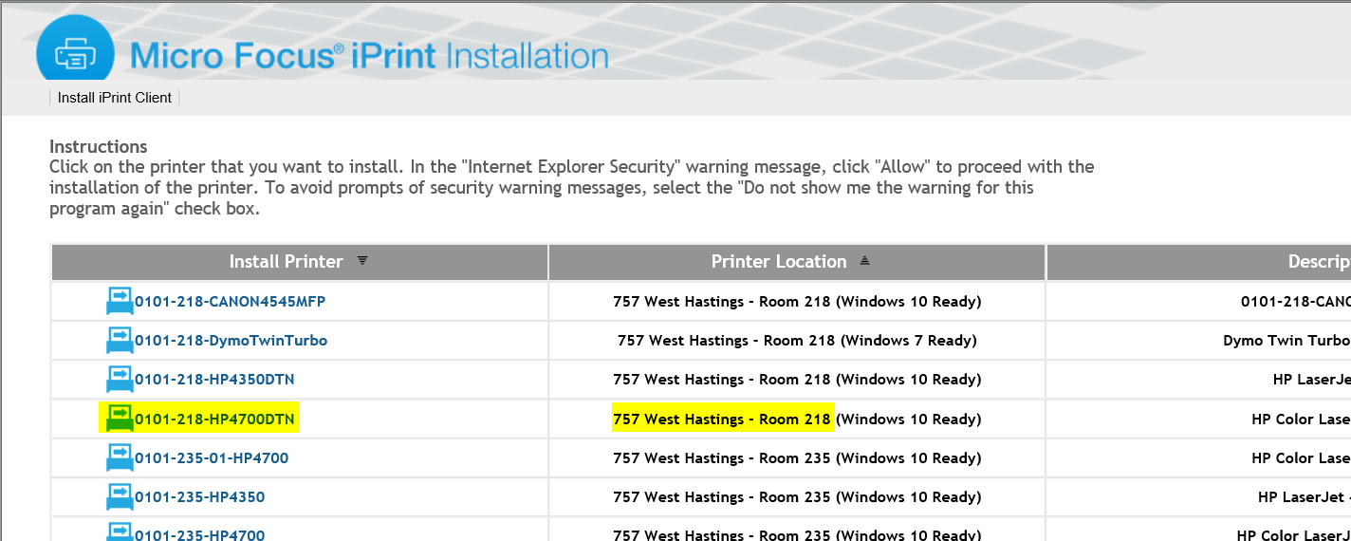

1. After you click on the link, you will receive the following warning message (if the printer is not already installed). When you see this warning message, confirm the printer is the one you want to install. If you want to set the printer you are installing to be the default printer, left click to place a check mark in the box next to **“Set printer as default”.**  Then left click the **“Yes”** button.

(note…the first printer installed will be the default)

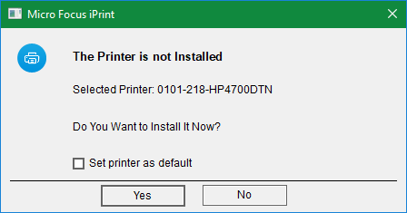

1. The printer drivers will then commence to download and configure onto your workstation

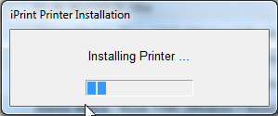

1. Once the printer driver has been downloaded and installed you will receive a message indicating the printer was installed…click **“OK”**

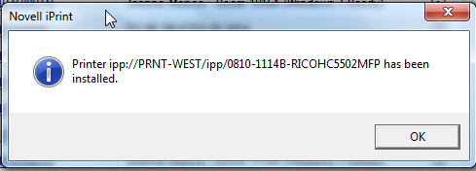

1. To verify if the printer install was successful, right click on the printer icon in the system tray (step 1) and left click on **“Launch Printer Folder”**

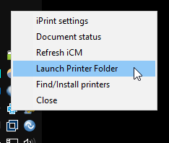

1. The “**Devices and Printers**” window will then open and you should now see the new printer you just installed, with a green check mark indicating your default printer:

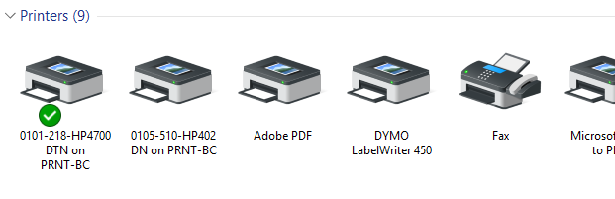

If you do not see the printer you just installed, go to the Service Gateway and proceed to open a ticket: <http://servicegateway-passerelledeservice.hc-sc.gc.ca/en/h-install-printers.html>

1. Repeat procedure for any other printers you wish to install